[1]

Robotics in the Treatment of Glioma

(October 2021)

Mohammed Omair Siddiqui

*Abstract*—In this survey, an overview of advanced robotic surgical technologies neurosurgical operation is provided. The task of finding the best technology available to ease the pain and suffering of glioma diagnosed patients is an ongoing one. Surgical treatment of brain tumors can be improved through the use of robotic technology and with greater precision and accuracy. In comparison to freehand or conventional neurosurgery, robotic manipulation may be superior when working in narrow surgical corridors. Using magnetic resonance compliant robot called as neuroArm which consist of built in iMRI system, haptic hand controllers, robot manipulators, monitors. An end-effector uses force sensors which can measure tool to tissue interaction forces and transmit this information to a surgeon sits at a workstation equipped with haptic feedback. The measured positional and force date is recorded of the bipolar forceps which is attached to the end-effector. A short explanation will be discussed about CyberKnife SRS system treatment process in glioma diagnosed pregnant women which has a high success rate in eradicating glioma, keeping the fetus safe at the same time by minimizing the dose.

# INTRODUCTION

D

uring the past fifteen years, robotics has grown rapidly in assisting doctors, nurses, and caregivers within the healthcare sector. However, the utilization of robotics has been largely behind the scenes. [1]

Since the development of first robotic surgical assistant over a decade ago, robots in healthcare are rapidly advancing. From new research today, the application of robotic technology in healthcare in recent years appears to be gaining steam. In the year 2000, Food and Drug Administration approved for the first robotics surgical system “Da Vinci Surgical Systems”. Over 20,000 surgeries are performed using the system. Research teams have developed variety of pioneering features for medical robotics over the years, which are designed to boost the standard of care, assist with surgeries, and patient satisfactionTop of Form

Bottom of Form

. [2] In the 1980s, the developments in technological facilities in the healthcare allowed surgeons to carry out minimally invasive surgeries utilizing small cameras, tiny surgical tools inserted through small incisions. Whereas in the olden days, surgeries were all about splitting the body and stitching it up upon completion of the operation. Medics all over the globe greeted these surgeries as a great achievement and an accomplishment in the healthcare sector as it leads to minor scars, a reduced amount of bleeding and pain, and shorter hospital stays. [3] During the past 30 years, there has been many enhancements in the robotics technology to assist surgeons in the treatment of various forms of cancers. [4] A cancerous tumor occurs when cells divide uncontrollably. This can lead to a damaged immune system, tumors, and other impairments that can be lethal. [5] Millions of people die of cancer around the globe, from 2016 to 2018 UK recorded 166,533 according to cancer research UK. [6] The ultimate cure of organ cancer completely depends on how the surgery is done, medics aim to not only remove the tumor in fact their objective is also to minimalize trauma, discomfort and lessen the post-surgery complications to give the patient a quality life. Compared to traditional surgery, robotics surgeries in treatment of cancer have shown remarkably less post-surgery complications. When robotics was first introduced in health sector, it was initially used for minor operation, but because of the recent day to day enhancement in the technology, robotics plays a major role in complex surgeries worldwide. The current state of robotic technology improves surgical outcomes for cancer surgery through improved 3DHD-visualization and intraoperative near-infrared fluorescence imaging, which provides visual confirmation of tumor tissue and related tissue perfusion. [7] Movement plays major role in robotic surgeries along with visualization and precision. Movements will assist surgeons to make minimal incision during the surgery [7].

In this review, we will discuss about the recent advancement and transformation journey of robotic systems and their significance in the surgery of glioma.

# WHAT IS GLIOMA

According to Cancer Research UK, Glioma is tumor which begin originating in brain, these starts in glial cells which support spinal cord and neurons in the brain. [8] The survival rate of glioma diagnosed patients decreases with age [9], for people aged between 20-44 tend to have 73% of chances of surviving, people between 44 to 54 years old the survival rate drops to 46% and the most vulnerable people belong to the age group of 55-64, however the rate of surviving widely depends on the grade and type of the tumor [10]. The composite nature of the brain has significant challenges to neurosurgeons [11]. Surgery for neurosurgical disease can be difficult because of the composite structure of the nervous system and its network [12]

The choice of how much resection should be performed during glioma surgery requires extremely trained surgeons. During the surgery, an associated risk is partial resection of the tumor which can further lead to reoccurrence of the tumor and in case of tumor reoccurrence it is often seen progression to a worse prognosis. Because of the infiltrative and aggressive nature of the tumor it always remains a challenge for medics. Throughout the treatment of glioma diagnosed patient, surgeons aim for maximum tumor resection, but because of the absence of tumor margins, surgical intervention can present a number of challenges, including a difficult time achieving complete resection without compromising surrounding tissues or causing neurological deficits. In addition to that, there is a risk of glioma cells displacing into the surrounding tissues which are glioma free(normal). Technology that improves tumor resection are very crucial in achieving best results. In neurosurgical procedures, “intraoperative magnetic resonance imaging” (iMRI) systems is under operation since early 1990's to improve the resection control as shown in the figure 1. The iMRI technique has shown a significant increase in resection in patients with high-grade gliomas. However, the process of procurement of the imaging from the iMRI disrupt the rhythm of the complex surgery which can cause further complication during the operation, it has been used to determine the degree of resection, instead of assisting and guiding surgeons during surgery. The only solution to this was if surgery could take place in an MR system itself which could enable surgeons to have a sight on the actual imaging of the brain at all times. After much efforts, the researchers at the University of Calgary developed a robot called neuroArm that is MR compatible. Merging robotics along with iMRI as shown in figure 2, patients can have optimal resection of glioma tumors while still maintaining eloquent brain regions. We are going to have a look into encounters could be faced related to robotic surgery, what advantages it could have over the traditional surgery, what further advancements can be achieved in order to improve safety and performance. [11]

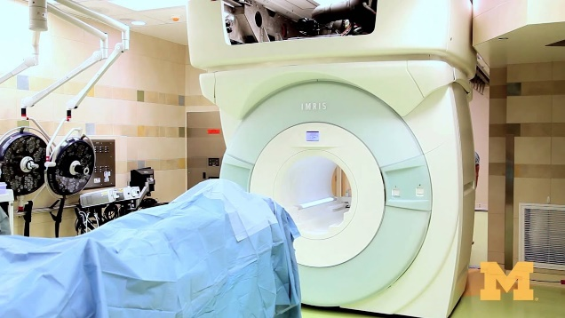Figure 1: Glioma diagnosed patient is undergoing iMRI scan during the surgery.

# why robotics

These robotic technology offers surgeons various features such as tremor filters and motion scaling which can highly improve surgical outcomes of the patient. Unlike the traditional way dealing with the diseases using iMRI, this robotic system enables the surgeons to access the imaging data during the surgery without affecting their workflow or surgery rhythm. The neuroArm unit consist 3D MRI display with surgical tool kit holder, haptic hand controllers, sight of the lesion field from multiple angles, monitor which displays images of the surgical zone to the surgeons which can be seen in the figure 3 surgeons controlling the hand controllers. [11]

## Achieving narrow surgical corridors

Employment of robot in neuroscience, grouping of surgical skills of the medics and the precision and correctness of the robot could help surgeons overcoming complex neurosurgeries with optimal outcome. Much progressed localization of lesion (damaged part) is possible to achieve through this technology which have resulted in dwindling surgical corridors, enabling surgeons to stretch beyond their capacity. The neuroArm is equipped with a specially designed tremor filter that allows smooth drive of the arm. During the surgery that is in software, the movement of the robotic arm is operated by surgeons through hand controllers. NeuroArm offers Motion scaling that assist surgeon to manipulate the tools fixed at the manipulator of the robot more accurate and definitely. Using this feature, actions at the hand-controller can be magnified into smaller actions of the end-effector, small motion at the hand-controller can be further magnified into even slighter motion. For instance, if the ratio is set to 20:1, then the Robot manipulator movement is limited to only 0.1 mm when there is displacement of 20cm in hand-controllers. These settings are done by the surgeons on basis of their studies on the specific case of the patient. High level of precision and control of the robot manipulator movement is offered by motion scaling which makes easier for surgeons to deal with narrow size of the surgical corridor, and limitation of hands by their natural anatomy. [11]

## Shift of brain during surgery

"Brain shift during surgery makes surgical navigation based on preoperative images invalid." [11] This problem is normally handled partly by the experience of the surgeons. In iMRI (systems) possessing units, new images can be obtained during the surgical procedures to "assess the degree of tumor resection and to re‑register the navigation system" . [11] In a number of cases, due to the fear of mistakenly causing harm to the eloquent brain, residual tumor is left untouched. Despite obvious complexities, this issue is possible to be remedied by making available robotic surgical apparatus that can bend around corners without being restricted by the line of sight. A snake-like apparatus in a conscious patient during an ongoing MRI is an apt example for the aforementioned. [11] As imaging and microsurgery can be performed simultaneously using a robotic system that is compatible with MR, the tooltip can be strategically positioned to resect residual tumors adjacent to the speech cortex and its connections. [11]

## Surgeon Fatigue

Generally, for access to the surgical corridor, the surgeon may have to stand awkwardly, sometimes for several hours, during the performance of surgery in conventional setups. Thereby causing unintentional errors to occur as a result of fatigue among surgeons. In neurosurgery assisted by robotic technology, the surgeon works at a more ergonomic workstation allowing for a more comfortable and efficient procedure therefore improving performance due to reduced surgeon fatigue. The use of monitors in conventional operating rooms often interferes with the rhythm of surgery because operators are required to look in a different direction to the surgical site analyse the visual display of imaging results. Compared to conventional surgery, the robotic workstation allows surgeons

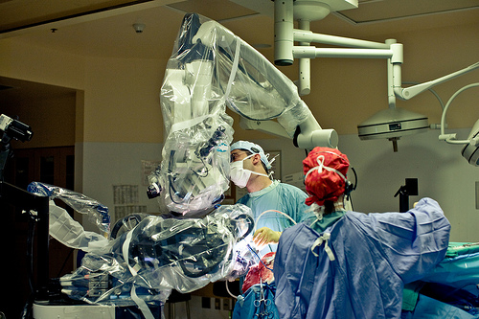 Figure 2: Surgeons during a robot assisted surgery by neoroArm.

to link imaging data and other sensory information efficiently. Additionally, haptic hand-controllers provide both the tactile sensation and the forces of tool tissue interaction at the workstation. With neuroArm’s force-scaling feature, the surgeons are equipped with a unique capability of altering or scaling the sense of touch if required. For instance, scaling up the forces can make fine tissues feel stiffer, and grading down the remote forces can make rigid matters like bone feel pulpy. The capacity to do this is determined by the fidelity and positioning of the force sensors, the design and bandwidth of the haptic controller, also how the force sensors are positioned relative to the surgical tool. [11]

# OTHER BENEFITS OF ROBOTIC SURGERIES IN TREATMENT OF GLIOMA

With image-guided robotic surgery, documentation is made easier, safety is increased, and education is enhanced. [11]

1. *Collecting data for case rehearsal*

With Robotic surgical system, it has now become possible to record the positional and force information during the procedure, something that is not possible in conventional surgery. Case rehearsal is done in a virtual simulator before the surgery, simulated practice may be mainly valuable to making the first experience of neophyte surgeons with robotic surgery more secure, less traumatic, and more effective in terms of safety and efficiency. The gathered data throughout the surgery can also play part in the development of the simulator system. The use of hand controllers which deliver touch sensation permits surgeons to exercise surgery with or without a robotic platform, providing experience in a failsafe setting as shown in figure 3. To generate force feedback, haptic device actuators must be defined in software system, based on physical properties of tissue models, which is a first step in all haptic hand-controller development. The recorded forces are then directed as command signals to the actuators situated in controllers. Realistic tool-tissue interaction can be developed in a virtual environment using the force and position data learnt during the robotic surgery which can also further utilized in order to obtain the physical properties of virtual tissue models. [11]

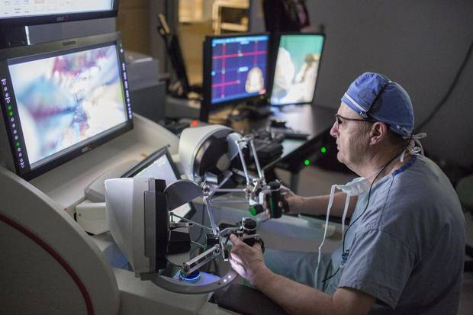 Figure 3: Surgeons controlling highly sensitive haptic hand controllers during a surgery.

1. *Haptic warning system*

A surgeon may unintentionally damage healthy brain tissues when excessive force is applied to nontargeted brain structures during surgical procedures. When neurosurgery is assisted by robotic technology, measurement of the forces between tool and tissue interactions can be done and transmitted to the workstation of the surgeon. For measuring these forces in actual time, each robotic arm in neuroArm is provided with double Nano 17 titanium force sensors (ATI Technologies Inc.). As stated earlier, with the help of no-go zones virtual fixtures, a significant decrease of risk of injury to healthy tissues is achievable. The technique may, however, seem inadequate when used to physically isolate the target anatomy from the nearby structures. In cases like these, instead of restricting the robot's orientation and position in physical space, an alert system that provides a notification every time when an interaction force exceeds a set standard for safety would prove to be of great help. Such a warning system can only be implemented if there is a clear understanding of the safe level of forces for different tissue types and brain structures. In robotic cases, recorded data can provide this information. By implementing and putting such an alert system to use, an operator's awareness of the force applied is improved thereby helping them avoid unintentional tissue punctures. [11]

1. *Technical methods*

*Concept of fixture of movement,*

Great improvement can be achieved in safety during a robot-assisted surgery using this technique. These fixtures can be made as an input in the software program in order to support the surgeon to perform a manipulation task. Using this technique, the position and force of robotic manipulator or arm can be restricted or locked while the task is going on.

In addition to that, using virtual fixtures restraints can be applied on the movements of the hand of a surgeon when moving to the surgical site during a surgery which can enhance the safety of the surgery. Hence, these can act as a guiding path for the surgeon’s hand and for the surgical apparatuses towards the lesion. Generally, in any neurosurgical treatment, the surgery is very complex because of the narrow surgical corridors and fear of damaging healthy tissues which are adjacent (close by) to the damaged tissue, using virtual fixture, all the unwanted motion can be eliminated in order to prevent harm to the strong part of the brain with the help of no-go zones. This also help the surgeons to complete the surgery in a shorter time efficiently.

Research shows that applying of virtual fixtures will eliminate

the vibration in the robotic manipulators. These virtual fixtures are used widely because of, they have no mass, they require no care assistance, they are very simple to produce, develop and modified basis of patient health status, their properties can be altered very quickly. [11]

When the end-effector is out of the described no-go zone, no-go zone has no effect on the robotic manipulators. Thus, it will be in surgeons hand to guide the end-effector till the surgical tool is not inside the no-go zone. As shown in figure 4, a simple no-go zone virtual fixture to prevent robot move into no-go zone when an unwanted instruction is sent (unwanted movement of hand). It can be under stood from figure 4 that a no-go zone cylindrically is defined which restrict the end-effector which is holding a bipolar forceps to displace out of the cylinder. [11]

*Concept of augmentation of force,*

With the support of virtual fixture, the surgeon while performing surgery can hold surgical apparatus in a safe zone. A safe zone for the surgeon's hand is normally defined by the sensory immersive workstation's haptic controller that ensures the surgeon's hand remains within the designated safe zone; hence, the surgical tool stays within the expected safe zone on the slave manipulator. By relying on a virtual fixture, the surgeon is able to move his or her hand controller implement very quickly, while ensuring patient safety at all times. Due to the actuation control system's latency, the slave manipulator would potentially be lagging. Robotic surgery can be more comfortable when a surgeon has additional control over the robot if the information from either the master or slave site is insufficient. Thus, since the virtual fixture does not affect the robot side, it cannot fix errors caused by the surgical instrument in any way. Implementation of augmentation force to the virtual fixture force can resolve this problem. As the position errors become larger than the controller's accuracy at the slave end effector, the augmentation force instructs the surgeon to slow down the hand motion of the haptic implement. [11]

# GLIOMA IN PREGNANT WOMEN

Women in their 20s to 39s suffer from intracranial tumors at the time of pregnancy, which were first described in the year 1898 and proving to be fatal in many cases. [13]. However, the chances are as low as 0.025% and 0.05%. It is recommended to perform surgical resection upon detection of symptoms and a large enough tumor to cause a mass effect, else the procedure may be delayed until after delivery. As we have discussed earlier that treating gliomas is sometimes complex as they present various challenges due to their location and aggressive nature. The latest research indicates that stereotactic radiosurgery (SRS)

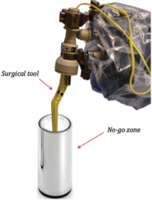

Figure 4: A cylindrical no-go zone is designed. [11]

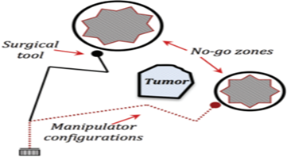

Figure 5: A simple illustration of no-go zone virtual fixture, various no-go zone fixtures can be made in a surgery. The main area is the dotted area where surgery is performed. [11]

during pregnancy is an effective treatment option for cancers of deep-seated origin. This treatment strategy includes staged SRS plus a deferred intensive chemotherapy protocol, which allows a pregnant woman with an aggressive brain tumor to deliver securely and have tumor regression.

A case of a 26year-old female suffering through sudden headache, nausea, and vomiting midst of the 13th week of pregnancy. Upon undergoing computerized tomography (CT) of the brain, tetra ventricular bleeding was observed along with a hypodensity in the right posterior hemisphere. Consequent magnetic resonance imaging (MRI) revealed an irregularly shaped brain tumor deep inside the right posterior hemisphere near the occipital horn of the lateral ventricle and measuring 2.5cm in the largest slice as well as bleeding within the tumor, which showed scattered spots of contrast enhancement. The volume of the glioma was found out to be 4.2 cm3. After stereotactic brain biopsy, patient was suggested with two options, discontinuation of the pregnancy trailed by open surgery, or closer monitoring with the surgery overdue after delivery. The patient decided to opt for the second option and refused the abortion and surgery was postponed. MR scan of the patient after a month revealed an increase in the size of the tumor during the follow-up session. The fast growth of the tumor indicated poor medical prognosis for both mother and the baby. [13] Considering all circumstances, surgeons proposed CyberKnife SRS was proposed, the treatment based on a staged SRS, rigorous chemotherapy, to allow tumor regression and at the same time safe delivery. Stereoscopic radiosurgery (SRS) was carried out by CyberKnife system (USA), which has a robotic radiosurgery system with no frame that is highly precise and robotic beam delivery. Throughout the treatment, the minimized dose received by fetus has already been described. During the CyberKnife SRS treatment of the patient, further tumoral progression during the 21st week of pregnancy could be seen with a volume of 14.1cm3. With the help of ultrasound imaging, a more detailed report of the exact position of the fetus beforehand radiosurgery were acquired with the aim of minimizing the dose delivered to the child. Surgeons prescribed the patient with a single dose of 1,400 centigray (cGy), as this dose was chosen with the intention of at least temporarily controlling tumor growth, a safe full-term pregnancy could be accomplished while exposing the fetus to an average of 4.2 cGy which is far below 10 cGy threshold for congenital malformation (condition that affects the baby from birth) and mental effects. [13]

The control of the growth of the tumor was successfully achieved until the baby was delivered at the 34th week of gestation. In three weeks following delivery, an intensive protocol of chemotherapy was initiated, consisting of ten cycles of 10 mg Avastin per kg and 125 mg Irinotecan per m2 every 14 days, as well as 150 mg Temodal per m2 every 28 days. A short time later, the patient's hemiparesis, affecting the left side, reappeared. When an MRI of the brain was done after almost a month and a half of delivery, it could be seen that the disease had progressed to a point where there was an increase of over 30% (21 cm3) in volume as well as existence of perilesional vasogenic edema. During this time, when a neurological examination was carried out, it confirmed the presence of hemiparesis on the left side along with hemi hypesthesia. During twelve weeks post-partum, when the volume of the lesion was 28.8 cm3, a hypo fractionated CyberKnife treatment with 2,400 cGy was administered to the isodose line at 82 percent which was then delivered in three parts of 800 cGy. The treatment was well tolerated by the patient. [13] After the subsequent control MR, the mass was markedly reduced in volume (down to 11.1 cm3) with a predominant colliquative central necrosis. It was also observed that both the left hemiparesis and hemi hypesthesia have also simultaneously regressed. With the help of additional studies, it was found that the lesion had necrosis but no vasogenic edema around it. Finally, the 33-month post-second SRS follow-up revealed that the tumor (pre-treatment volume: 28.8 cm3) had disappeared. This finding was further confirmed by images taken at 38 months. The most recent MR scan conducted 43 months after the second SRS shows no evidence of solid tumor growth. One can observe long-term tumor deterioration and vanishing after second SRS plus chemotherapy, since tumor growth initially stabilizes after first SRS, recurs after delivery, and then persists for a very long time before eventually disappearing after the second SRS plus chemotherapy. After 43 months of receiving CyberKnife treatment, the long-suffering woman is now in good state of health and 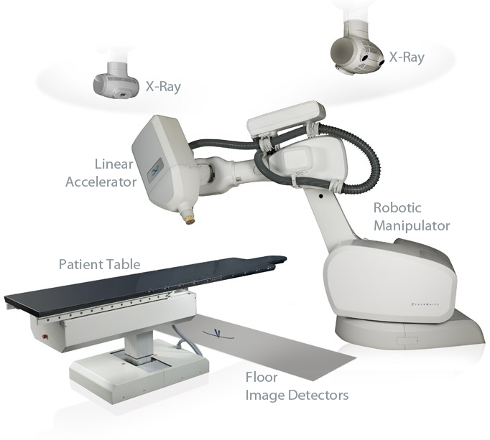 Figure 6: Diagram of a typical CyberKnife system

is living a normal life with her almost 4- year-old toddler, who exhibits a normal development of his cognitive and neuropsychological functions. Follow-up MRIs are conducted frequently to ensure no further recurrences occur. [13]

Using the CyberKnife SRS system, a pregnant woman with high-grade gliomas (World Health Organization Grade III) was treated followed by the early use of bevacizumab, temozolomide and irinotecan. For achieving temporary tumor control until the delivery of the child, a primary dose of 1,400 cGy was administered. With a second dose of 2,400 cGy in three segments, coupled with rigorous chemotherapy, the tumor was completely eradicated and her condition was stabilized. [13]

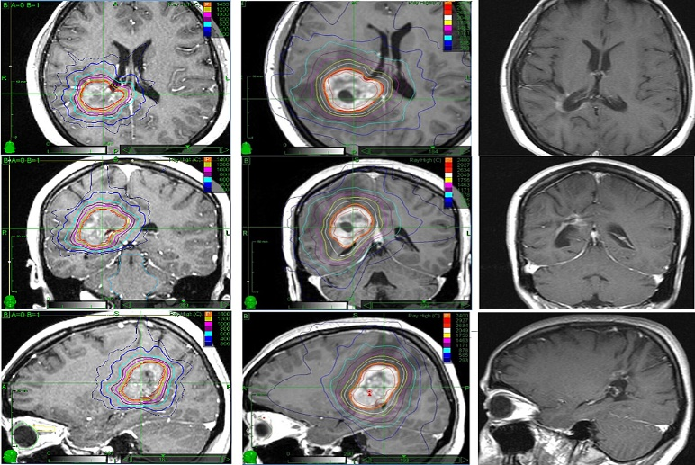Figure 7: MR images of a patient at different stages.

# CLINICAL CASE STUDY

## Experimental Setup

This setup comprises of two Magnetic Resonance Imaging compatible manipulators fitted with microsurgery abilities. The material from which the manipulators are made is of titanium and polyoxymethylene. They are attached to a mobile base that is height adjustable and equipped with camera and an arm. Specially built Set of tools with a tool holder. Haptic hand controllers are at the workstation which is highly precise and allows surgeon tool-tissue interaction remotely, the workstation also comprise of two monitors, out of which one is for display of intraoperative imaging from the MR system and the other one’s job is to display the multiple view of the lesion site associated with mounted cameras. The system is having a robot control user interface on a touchscreen display for virtual display of the robotic manipulators. At the workstation there are pedals (when disengaged the movement of the robotic manipulators will be stopped) to stop the operation of the robotic manipulators in case of emergency hence making a fail-safe environment. [12] “An Omega 7 haptic device provides 7 degrees of freedom (DOFs) positional sensing and 4 DOFs force feedback”. The haptic device implement that is designed to cover the natural movement of the human hand pivoting around the wrist. Forces as high as 12 N can be produced by the haptic device, and a grasping force feedback up to 8N. Surgeon, while seated at the workstation, uses haptic hand controllers to send motion information to slave manipulators. A translation from velocity to displacement is performed on the hand controllers, which is then mapped into the coordinate system attached to each end-effector. Motor signals gets generated from velocities. The absolute encoders measure the displacement of the robotic manipulators and is then sent to master site to update the latest position and orientation of robotic manipulator and augmented virtual reality arms. Forces at the tool tip can be measured with the help of the force sensors attached on end-effector and in tool contact. The neuroArm system two surgical apparatuses can be held each by one of its manipulators. For this setup, the tools used are bipolar forceps and a suction tool, bipolar on the right manipulator and suction tool on the left. Since bipolar forceps plays the primary role in dissection of brain tissue whereas the function of suction tool is to suck-out unnecessary residual fluids from surgical spot. Therefore, data of force and position of bipolar forceps is only measured.

## Test Procedure The results are derived from a robot assisted glioma surgical operation executed by neuroArm. An approximately 33-minute duration robot assisted surgery was carried out, not counting craniotomy and wound closure time. The operation task involved manipulation, and picking and placing of cotton strips. [11]

## Result As we can see from the figure 8, it illustrates measured positional data of the end-effector of the robotic manipulator holding the bipolar forceps which recorded over 100-s period of the surgery. The bipolar forceps travelled 9.8mm, 11.1mm and 11.8mm along the x, y and z axis as observed in figure 8. The force is measured with help of a force is sensor situated at the neuroArm manipulator in the figure 9. [11]

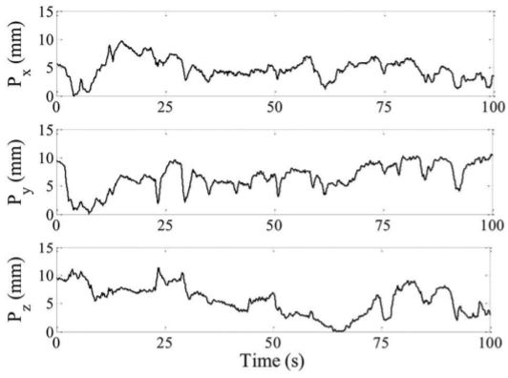 Figure 8: Position components of the bipolar forceps located at the end-effectors of the right neuroArm manipulator. [11]

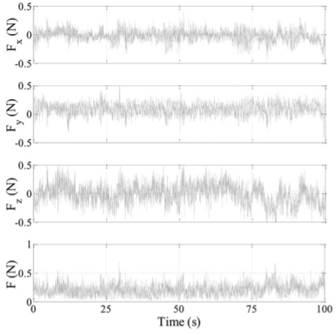 Figure 9: Force measured by the force sensor for the trajectory given in Figure 7. [11]

# CONCLUSION

The purpose of this survey is to emphasize the importance of implementing robotic technology in neuroscience. A robotic surgical system is an optimal alternate when surgical corridors are narrow, brain shift is unavoidable or when fatigue positioning needs to be adhered during conventional surgery. The robotic system provides exclusive solutions in order to improve safety and surgical outcomes using special features like haptic high-force warning system. A special feature virtual fixture and augmentation force which create path for surgeon’s hand movement and preventing unwanted hand movement and keeping the tool in safe zone. Robotic technologies in treatment of glioma in pregnant women is found out to be more fruitful than anticipated, as discussed earlier in the case of 26year-old pregnant woman, eradication of glioma completely was possible hence completely stabilizing her disease, in addition to that, keeping doses at lower level than average threshold to make sure the baby is safe resulting in a successful full-term delivery of her child. The clinical case study conducted, a surgeon’s hand position and tool’s action (forces) on the tissue were able to be recorded by the neuroArm robot to resect glioma. These interactive mean values were possessing mean values much less than 1N as can be seen in figure 9 in x, y and z ais. The recorded measurement of position and force were noted down, and will be used in case rehearsal of robot-assisted glioma surgery and education purposes. [11]

# References

|  |  |
| --- | --- |
| [1] | D. S. Bieller, “The Role of Robots in healthcare,” 31 May 2021. [Online]. Available: https://ifr.org/post/the-role-of-robots-in-healthcare-part2. [Accessed 24 10 2021]. |
| [2] | D. P. P. Sujatha Alla, “Healthcare Robotics: Key Factors that Impact Robot Adoption in,” in *IISE Annual Conference*, Norfolk, 2021. |
| [3] | S. Rochman, “Robotic Surgery and Cancer,” American Association of Cancer Research, 16 July 2020. [Online]. Available: https://www.cancertodaymag.org/Pages/Summer2020/Robotic-Surgery-and-Cancer.aspx. |
| [4] | A. M. A. J. M. A. F. M. A. Yusuf Jamal, "Robots in Cancer Surgery: A Boon or Bane," *Journal of Cancer thereapy,* vol. 11, no. 10, p. 21, 2020. |
| [5] | R. Nall, "Medical News Today," 6 January 2020. [Online]. Available: https://www.medicalnewstoday.com/articles/323648. |
| [6] | Government, UK, "Cancer Research UK," 2016-2018. [Online]. Available: https://www.cancerresearchuk.org/health-professional/cancer-statistics-for-the-uk. |
| [7] | J. Hoeppner, "Robotic Cancer Surgery," *Cancers,* p. 2, 30 september 2021. |
| [8] | Cancer Research UK, "GLIOMA," 30 October 2019. [Online]. Available: https://www.cancerresearchuk.org/about-cancer/brain-tumours/types/glioma-adults. |
| [9] | Canccer.net, "Brain Tumour: Statistics," January 2020. [Online]. Available: https://www.cancer.net/cancer-types/brain-tumor/statistics. |
| [10] | The American Cancer Society medical and editorial content team, "Survival Rates for Selected Adult Brain and Spinal Cord Tumors," Cancer.org, May 2020. [Online]. Available: https://www.cancer.org/cancer/brain-spinal-cord-tumors-adults/detection-diagnosis-staging/survival-rates.html. |
| [11] | Y. M. L. S. G. S. L. K. Z. Garnette R. Sutherland, "Robotics in the neurosurgical treatment of glioma," p. 7, February 2015. |
| [12] | K. Z. L. S. G. C. S. Yaser Maddahi, "Treatment of Glioma Using neuroArm Surgical System," p. 9, April 2016. |
| [13] | P. M. C. V. Romanelli P, "Staged Image-guided Robotic Radiosurgery and Deferred Chemotherapy to Treat a Malignant Glioma During and After Pregnancy," February 2018. |
| [14] | D. S. Bieller, “www.ifr.org,” 31 May 2021. [Online]. Available: https://ifr.org/post/the-role-of-robots-in-healthcare-part2. [Accessed 24 10 2021]. |
| [15] | S. Rochman, “Cancer Today,” American Association of Cancer Research, 16 July 2020. [Online]. Available: https://www.cancertodaymag.org/Pages/Summer2020/Robotic-Surgery-and-Cancer.aspx. |
| [16] | U. Government, "Cancer Research UK," 2016-2018. [Online]. Available: https://www.cancerresearchuk.org/health-professional/cancer-statistics-for-the-uk. |

1.